Hitting The Jackpot
Introduction
Rules of the Game
Choosing 6 “Normal” numbers from 1 – 37 (with no order significance) and 1 Special number from 1 – 7.
Cost
Each 2 combinations (“tables”) costs 6 NIS.
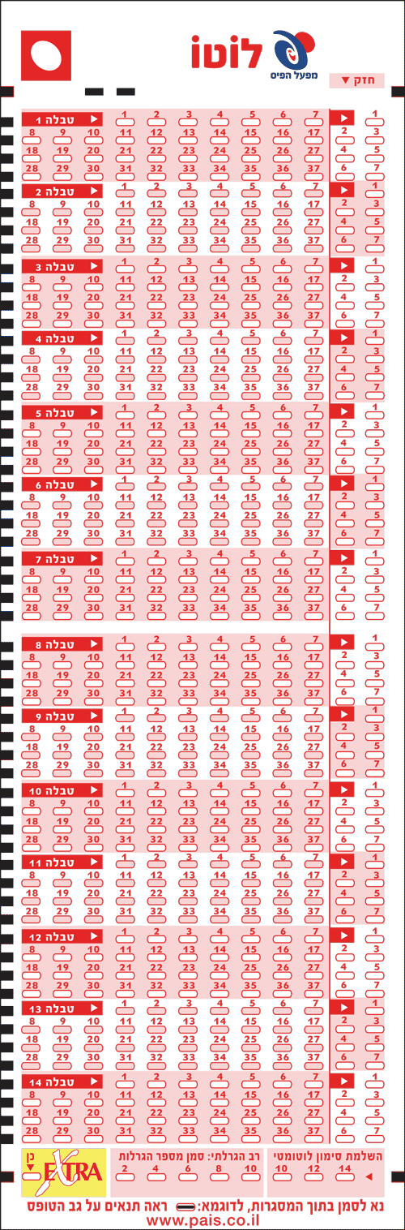


Data Analysis – The special number
Distribution
The following diagram presents the distribution of the special number since the new rules of the lottery (1 – 7). In past times the special number could be each number between 1 – 50.

Time and Frequency domain analysis
- The Mathematical Formula
- FFT:
The Discrete Fourier Transform (DFT), which the FFT calculates, is defined as:
$$X\left[k\right]=Σ_{n=0}^{N-1}x\left[n\right]⋅e^{-j\frac{2π}{N}kn}$$
If we look at frequency zero k=0), the formula simplifies significantly because $e^{0}=1$:
$$X\left[k\right]=Σ_{n=0}^{N-1}x[n]$$
This means X[0] is simply the sum of all your data points. By subtracting the mean ($μ$) from every point $x[n]$ before the FFT, the new sum becomes:
$$Σ_{n=0}^{N-1}(x\left[n\right]-μ)$$
As a result, $X[0]$ becomes zero, the giant spike disappears, and you can finally "zoom in" on the actual periodic patterns in the rest of the spectrum
In signal processing, the Mean of a signal is its DC Component (Direct Current). In your lottery data, this represents the average value of the numbers drawn.
We subtract it for two main reasons:
- Scaling: The DC component usually has a very high magnitude. In a plot, "spike" (huge increment) at frequency 0 is so large that it squashes all the other interesting frequencies (the "AC" parts), making them impossible to see.
- Focus: We aren't interested in the fact that the average lottery number is, for example, 1. We are interested in the fluctuations(תנודות) and patterns around that average.
- The Communication Analogy:
Think of this like a Radio Receiver (Baseband conversion):
- The DC (Mean): This is like the Carrier Signal ($f_{c}$). It carries the energy but doesn't contain the actual information (the "message").
- The Fluctuations: These are the Sidebands or the Information.
- The Action: Subtracting the mean is like Down-conversion or Carrier Suppression. By removing the "Carrier" (the fixed average), you are left with the Baseband signal—the raw information about which numbers appear and when.
- Time & Frequency transformations

DC means that the ball comes out each one of the lotteries.
$$f=\frac{k}{N}=\frac{dicrete frequency}{number of samples \backslash lotteries}$$
For example, huge value in the frequency of 0.1 means:
$$f=\frac{k}{N}=\frac{1}{10}→the ball^{'}s number repeat each 10 lotteries.$$
- Visual Graphs - in the file. To put it here and to start analyze each one of them, maybe the export the graphs to csv for the AI model to train on that data, or only to give him the most common freqs of each ball.

Data Analysis – the normal numbers

